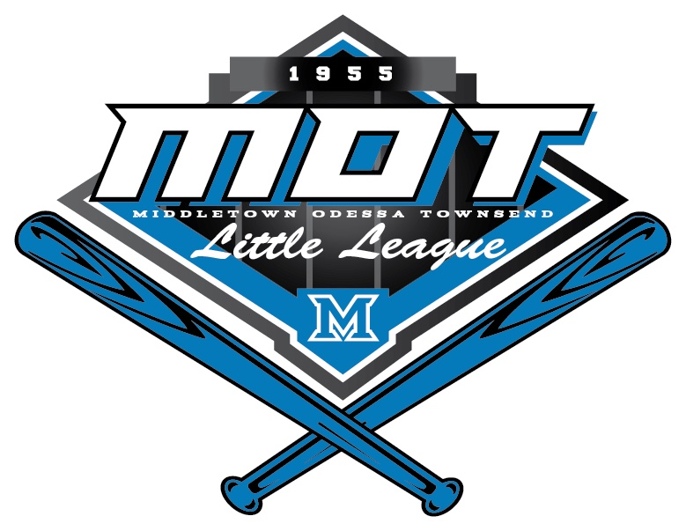

**SAFETY PLAN**

**2021**

**Prepared by:**

**Brian Yarborough**

**Safety Officer**

**League I.D. - 208-01-10**

**GENERAL INFORMATION**

**SAFETY GOALS:**

1. Provide a safe environment so that our players can learn and enjoy the games of baseball and softball

2. Provide clear instructions to the coaches in order to effectively deal with any injuries in a prompt and safe fashion.

3. Provide a system for reporting any injuries quickly and in a well-documented manner.

4. Provide immediate first aid to any injured player.

5. Provide a clear procedure for handling any serious injuries.

6. Provide an injury avoidance plan.

7. Provide First Aid Training for Managers, Coaches, and Umpires

8. Provide Coaching Fundamentals Training by League Coordinators (see p. 24)

**IMPORTANT PHONE NUMBERS:**

**1. SAFETY OFFICER**– Brian Yarborough 302.383.9875 safetyofficer@motlittleleague.com

**2. EMERGENCIES: (posted in concession stands at Duke & Silver Lake complexes & field gang boxes)**

**Police and Ambulance - (911)**

Middletown Police - (302) 378-8399

Middletown Fire Co. - (302) 378-7799

State Police - Troop 9, Odessa - (302) 378-3075

League President – Steven Lappert - (302) 353-9486

**HOW TO AVOID**

**ACCIDENTS AND INJURIES**

1. **Inspect the Field Prior to Every Game**

(Responsibility of Home Plate Umpire and managers)

1. Look for unsafe holes or stones on the field
2. Dress the Pitcher’s mound and Batter’s Boxes
3. Check all dugout and outfield fences
4. Check dugouts for debris
5. Be sure bases are properly anchored
6. **Inspect Player Equipment Prior to Every Game**
7. Check Catcher’s gear for proper straps and hardware

**(gear must be worn by a player, NOT a coach, when warming up pitchers and during PRACTICE)**

1. Catcher’s mask **must** have a safety flap for the throat area
2. All bats and helmets must be properly stored in the dugout area. **NO** **WEIGHTED DONUTS ARE PERMITTED**. Only weighted sleeves are allowed.
3. Catchers must wear protective cups
4. **NO ON-DECK CIRCLES** (Major, Minor, Rookie, Instructional & Tee-Ball)

**3. Have a Pre-Game Discussion - (Responsibility of Home Plate Umpire)**

1. Should include umpires and coaches for both teams
2. Encourage everyone to create a positive atmosphere
3. Discuss any time limits or curfews
4. Discuss sportsmanship and establish umpire’s control of the game
5. Review ground rules
6. Establish location of emergency phone or cell phone

# **WHAT TO DO IN CASE OF AN ACCIDENT OR INJURY**

**AT SILVER LAKE COMPLEX:**

1. Call 911 for any serious injuries. Always error on the side of caution. Phone is located in the concession area or use cell phone. Trauma First Aid Kits available at Concession Stands and in the sheds behind home plate at the Jr/Sr Baseball and Front Softball fields.
2. Provide first aid as necessary. Ice and First Aid Kits are available in the Concession Area & Gang Boxes at each field. Please notify the Safety Officer if we are running low or out of Ice Packs and supplies for the First Aid Kits.

(**First Aid Kit to be checked periodically throughout the season by Safety Officer**)

1. For cardiac events, an AED is available in the shed behind home plate at the Jr/Sr. Baseball field. The Safety Officer must be notified **IMMEDIATELY**, if the AED is used. CPR should only be performed by trained, certified personnel.
2. Contact Parents of injured player.
3. Fill out an accident report & notify the Safety Officer as soon as possible, but no more than 48 hours after the incident. Report forms available on MOTLL website.
4. Discuss the situation with your team to ease anxiety.
5. The Safety Officer will contact the player’s parents for follow-up and advisement on next steps. Parents will be reminded M.O.T. Little League Insurance is only supplemental to individual’s Health Insurance Policy.

**AT DUKE FIELD COMPLEX:**

1. Call 911 for any serious injuries. Always error on the side of caution. Phone is located in the concession area or use cell phone. Trauma First Aid Kits available at Concession Stand & in garage next concession stand.
2. Follow steps 2 - 7 above. The AED is located in the garage next to the concession stand

**COMMON SENSE SAFETY PRACTICES AND TIPS**

**DURING EVERY GAME**

* 1. All players and coaches not in the field must stay behind the fences in the dugout at all times.
  2. Managers are responsible for proper sportsmanship from their players & parents.
  3. **NO ON-DECK BATTERS** in Tee Ball, Instructional, Rookie, Minor & Major divisions. Juniors / Seniors on-deck batters must be in a protected area and must wear NOCSAE protective batting helmets.
  4. Warm-up of relief pitchers may be done only in approved areas. Catchers must wear protective equipment. If the pitcher and catcher are exposed to batted balls, another player must protect the warm-up area and wear a batting helmet. **Adults are NOT permitted to warm up pitchers at any time, including practices.**
  5. Only players, the manager, two (2) coaches and one (1) scorekeeper of participating teams are permitted in the dugouts. Parents, family members & fans are not permitted in the dugout at any time.
  6. Both teams are responsible for raking the infield, batting area, and mound before and after every game.
  7. Players may not wear watches, rings, pins, jewelry (including necklaces, bracelets & earrings), hard cosmetic or decorative items at any time.
  8. Base runners and batters must wear protective NOCSAE helmets at all times.
  9. Pitchers in the Tee Ball & Instructional Leagues are required to wear a face mask or a helmet with a face mask. We purchased extra masks for any other players wishing to wear one.

**DURING CONCESSION DUTY**

1. Locate Fire Extinguisher to be used in the event of an emergency
2. Do not work in overcrowded conditions
3. All workers must be at least 16 years old unless under direct adult supervision. No children under 12 are allowed in the concession stand.
4. Show courtesy to customers at all times.
5. Be aware that French Fryer, Heat Lamps, Grill, and Water are or may be **EXTREMELY HOT!**
6. Closed toe shoes are required. No bare feet or open-toed shoes at any time
7. Remember to wash your hands prior to handling food, or between other activities.
8. The last shift is responsible for clean-up and preparation for the next concession duty. This includes:

a. Washing down grills, counter tops, and utensils

b. Be sure the heat lamps, french fryer, and other electrical appliances are turned off

c. Restock drink coolers, fill condiment containers, fill napkin holders, and be sure soda containers are not empty.

**SAFETY ADDITIONS FOR 2021**

1. Continued mandatory Volunteer Application form and sex abuse check. Expanded check to include the National register. The League expanded process to a complete background check for this season. Ms. Linda lappert (Volunteer Coordinator) performed checks of all Officers, Board Members, Coaches, Umpires and other volunteers via the internet using the JDP service. This check will be performed periodically up to the season starting in April 2021. (**Failure to fill out this form, or being listed as an offender, will result in immediate suspension from all League Activities. Volunteers will not be allowed to serve in their capacity until the background check has been completed.**)
2. Distributed information package to all managers on draft day including the following documents:

a. Listing of 2021 Officers and League Coordinators

b. Outline of Fundamentals Training (3/16/21) & First Aid Clinic (3/16/21)

c. Incident / Injury Tracking Form **(also are to be used to record “near miss” occurrences; these to be submitted to Safety Officer for tracking purposes)**

d. AIG Accident Notification Form

e. Parent Information and Mandatory Volunteer Form

f. New First Aid Kit and Ice Packs

g. Location of AED devices at Silver Lake & Duke Complexes

h. 2021 Safety Plan & all Insurance and accident forms are posted on website.

i. Medical release for to be completed by parent and retained by manager.

1. All baseball & softball Managers and Coaches will attend a “Fundamentals Clinic” given by certified baseball coaches on March 16, 2021. A form verifying attendance has been developed. This form will be compiled by each Division Coordinator and filed with the Safety Officer to assure attendance by every team and also each coach and manager at least once every 3 years.
2. Created a Training Officer position on the League’s Board of Directors to run clinics and provide “professional development opportunities” for all managers & coaches.
3. Updated the mandatory Coaches Code of Conduct for all managers and coaches.

.

1. Continued use of mandatory Parent / Player Code of Conduct.
2. Continued use of attendance verification form for First Aid Training to be held March 16, 2021. This form to be compiled by each League Coordinator and filed with the Safety Officer to assure attendance by each team and also each coach and manager at least once every 3 years.
3. Working with the local high school athletic director or computer based training tools to provide CPR & AED training on March 16, 2021 for managers & coaches.
4. Introduced the use of weather apps to detect lightning nearby. We purchased fog horns to notify all fields to leave the premises when lighting is visible or is within 10 miles of the facility. We will continue a coordinated effort to ensure both complexes are evacuated at the same time.

1. All Board Approved Volunteers will be required to wear an ID badge.
2. All Managers, Coaches and Team Parent must attend a Safety Meeting.
3. Added batters eyes to each field at the Duke & Silver Lake complexes.
4. Resodded Silver Senior baseball & Duke Major baseball field to repair damages from excessive use.
5. Town of Middletown Parks and Recreation Department will maintain fields and conduct necessary repairs to ensure player safety.
6. Safety Officer works with the Town of Middletown Parks & Recreation Department to inspect all the fields and lights before the season starts.

**ACCIDENT REPORT AND PARENT INFORMATION FORMS**

1. Incident / Injury Tracking Report (to be used to record accidents that might result in a future insurance or liability claim and also to track “Near Misses”; available on league website)

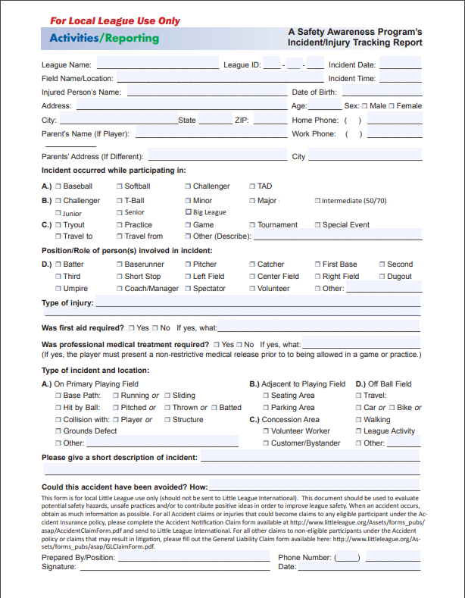

2. AIG Accident Notification Forms (to be used only if an accident needs to be reported to Little League Headquarters for insurance claim purposes; available on league website)



3. Parent Information Packet (includes insurance information; available on league website)

# Little League® Baseball & Softball

**CLAIM FORM INSTRUCTIONS**



**WARNING** — It is important that parents/guardians and players note that: *Protective equipment cannot prevent all injuries a player might receive while participating in baseball/softball.*

To expedite league personnel’s reporting of injuries, we have prepared guidelines to use as a checklist in completing reports. It will save time -- and speed your payment of claims.

The National Union Fire Insurance Company of Pittsburgh, Pa. (NUFIC) Accident Master Policy acquired through Little League® contains an “Excess Coverage Provision” whereby all personal and/or group insurance shall be used first.

The Accident Claim Form must be fully completed, including a Social Security Number, for processing.

To help explain insurance coverage to parents/guardians refer to *What Parents Should Know* on the internet that should be reproduced on your league’s letterhead and distributed to parents/guardians of all participants at registration time.

If injuries occur, initially it is necessary to determine whether claimant’s parents/guardians or the claimant has other insurance such as group, employer, Blue Cross and Blue Shield, etc., which pays benefits. (This information should be obtained at the time of registration prior to tryouts.) If such coverage is provided, the claim must be filed first with the primary company under which the parent/guardian or claimant is insured.

When filing a claim, all medical costs should be fully itemized and forwarded to Little League International. If no other insurance is in effect, a letter from the parent/guardian or claimant’s employer explaining the lack of group or employer insurance should accompany the claim form.

The NUFIC Accident Policy is acquired by leagues, not parents, and provides comprehensive coverage at an affordable cost. Accident coverage is underwritten by National Union Fire Insurance Company of Pittsburgh, a Pennsylvania Insurance company, with its principal place of business at 175 Water Street, 18th Floor, New York, NY 10038. It is currently authorized to transact business in all states and the District of Columbia. NAIC Number 19445.This is a brief description of the coverage available under the policy. The policy will contain limitations, exclusions, and termination provisions. Full details of the coverage are contained in the Policy. If there are any conflicts between this document and the Policy, the Policy shall govern.

The current insurance rates would not be possible without your help in stressing safety programs at the local level. The ASAP manual, **League Safety Officer Program Kit**, is recommended for use by your Safety Officer.

# TREATMENT OF DENTAL INJURIES

Deferred Dental Treatment for claims or injuries occurring in 2002 and beyond: If the insured incurs injury to sound, natural teeth and necessary treatment requires that dental treatment for that injury must be postponed to a date more than 52 weeks after the date of the injury due to, but not limited to, the physiological changes occurring to an insured who is a growing child, we will pay the lesser of the maximum benefit of $1,500.00 or the reasonable expense incurred for the deferred dental treatment. Reasonable expenses incurred for deferred dental treatment are only covered if they are incurred on or before the insured’s 23rd birthday. Reasonable Expenses incurred for deferred root canal therapy are only covered if they are incurred within 104 weeks after the date the Injury is sustained.

**CHECKLIST FOR PREPARING CLAIM FORM**

1. Print or type all information.
2. Complete all portions of the claim form before mailing to our office.
3. Be sure to include league name and league ID number.

# PART I - CLAIMANT, OR PARENT(S)/GUARDIAN(S), IF CLAIMANT IS A MINOR

1. The adult claimant or parent(s)/guardians(s) must sign this section**, if the claimant is a minor.**
2. Give the name and address of the injured person, along with the name and address of the parent(s)/guardian(s), if claimant is a minor.
3. Fill out all sections, including check marks in the appropriate boxes for all categories. **Do not leave any section blank. This will cause a delay in processing your claim and a copy of the claim form will be returned to you for completion.**
4. It is mandatory to forward information on other insurance. Without that information there will be a delay in processing your claim. If no insurance, written verification from each parent/spouse employer must be submitted.
5. Be certain all necessary papers are attached to the claim form. (See instruction 3.) Only itemized bills are acceptable.
6. On dental claims, it is necessary to submit charges to the major medical and dental insurance company of the claimant, or parent(s)/guardian(s) if claimant is a minor. “Accident-related treatment to whole, sound, natural teeth as a direct and independent result of an accident” must be stated on the form and bills. Please forward a copy of the insurance company’s response to Little League International. Include the claimant’s name, league ID, and year of the injury on the form.

# PART II - LEAGUE STATEMENT

1. This section must be filled out, signed and dated by the **league official**.

**2.** Fill out all sections, including check marks in the appropriate boxes for all categories. **Do not leave any section blank. This will cause a delay in processing your claim and a copy of the claim form will be returned to you for completion.**

**IMPORTANT**: Notification of a claim should be filed with Little League International within 20 days of the incident for the current season.

4. Parent / Player Code of Conduct Form (required to be signed at player registration & available on league’s website)

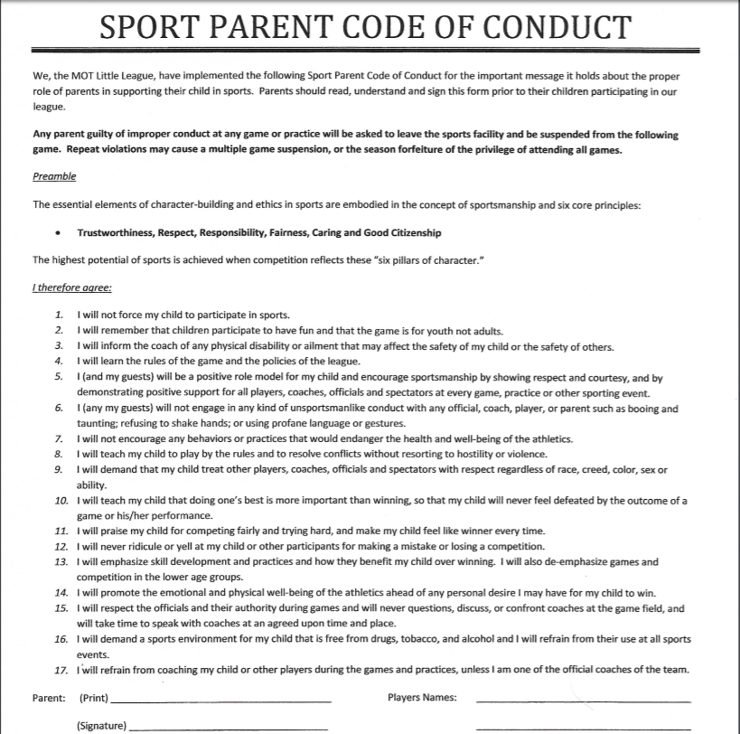

1. Coaches Code of Conduct Form (required to be signed at player registration & available on league’s website)

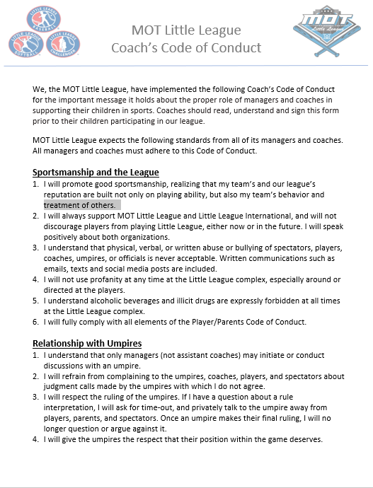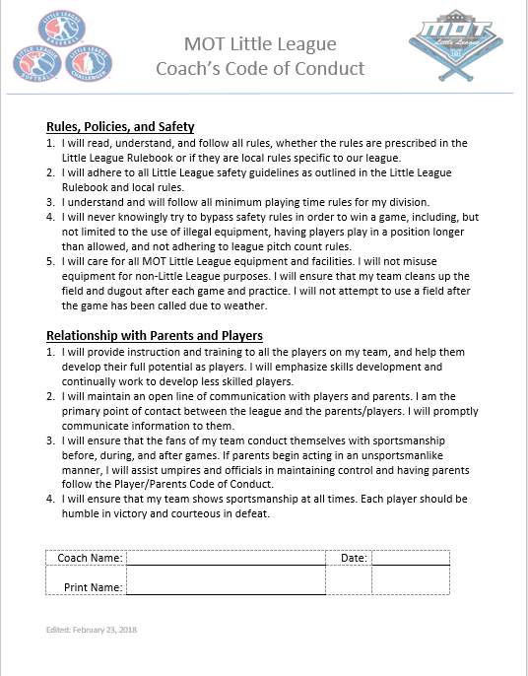

**2021 M.O.T. LITTLE LEAGUE EMERGENCY CONTACTS**

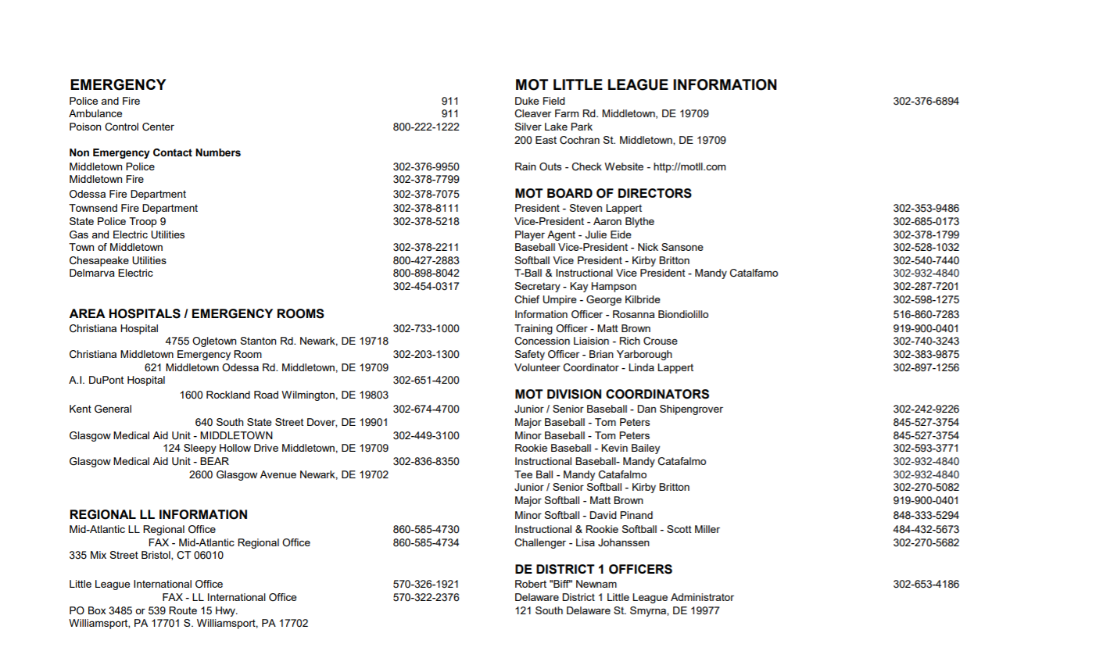

**This list consists of:**

* **Emergency Contacts**
* **League Officers**
* **Division Coordinators**

**Lists are posted at each concession stand & on the league’s website at** [**http://motll.com**](http://motll.com)

**VOLUNTEER APPLICATION – 2021**

**Used for new & returning volunteers**

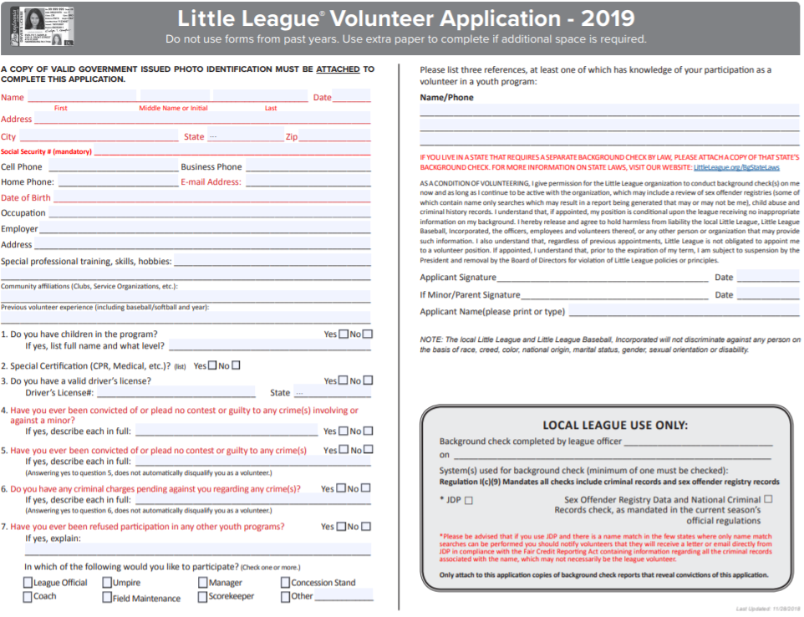

**Verification of First Aid Training**

**HELD:** March 16, 2021 @ Middletown Town Hall

**INSTRUCTORS:**

Brian Yarborough – Safety Officer

MOT Little League

**FIRST AID KITS:** New kits provided to all League   
 Managers on March 16, 2021

Attached outline also distributed to all Managers on

Draft Day

Developed attendance verification form (see page 22)



**Coaches First Aid Clinic Outline**

**2021**

**Prepared by:**

**Brian Yarborough**

**Shane Tuffy**

Most Common Sports Injuries – Sprains, Strains, and Contusions (Bruises) = **PRICES**

***KEY – Getting Back to the diamond as soon as possible***

* **P – PROTECTION: The use of protective gear and safety awareness can prevent many common injuries from occurring**
* **R – REST: The first 24 – 48 hours after an injury is considered the crucial period.**
* **I – ICE: The first 48 hours after the injury, you must ice and elevate 20 minutes at a time every 3 to 4 hours. Do not ice for more than 20 minutes because you do not want to damage the tissues.**
* **C – COMPRESSION: Use compression when elevating**
* **E – ELEVATE: For example, an ankle injury needs to be elevated higher than the heart as often as possible. This is especially important at night.**
* **S – SUPPORT: Crutches and other assistive devices may help injured player move around and heal without adding damaged to the injured area**

**What are Sprains, Strains, and Contusions?**

* Sprains – occurs at our joints. Injury to ligament. Overstretching to tear of the ligament. Ligaments hold our joints together like rubber bands. (Degrees – 1st Degree – Mild, 2nd Degree – Moderate, 3rd Degree – Severe)
* Strains- injury to our muscle (overstretching or tearing of the muscle)
* Contusions – injury to soft tissue. Resulting in bruising.

**Other Common Injuries:**

* Fractures
* Dislocations (LOOK, LISTEN, FEEL)
* Injuries to small joints
* Facial Injuries
* Injuries to teeth
* Eye injuries
* Insect bites & stings
* Heat Illness
* Head Injuries & Concussions (doctor’s release required for return)
* Spinal Injuries
* Seizures
* Asthma Attacks
* Diabetic Incidents
* Choking
* Allergic Reactions (Bee Stings, Food allergies, etc…)
* Other Health Diagnoses

**Heat Index Policy:**

* The league reserves the right to close fields and cancel games & practices when the heat index approaches dangerous level (at, around or above 100 degrees)

**Tips to Prevent Injury:**

* Proper maintenance of playing / practice sites & inspection of fields
* Pay attention to playing & weather conditions
* Ensure players know basics & benefits of good nutrition
* Proper athletic conditioning (stretching, warm-up, agility drills, etc…)
* Avoid over use (pay attention to activities outside Little League)

**Some DO’s and Don’ts**

DO…..

Reassure and aid children who are injured, frightened, or

lost. Provide, or assist in obtaining, medical attention for those .

who require it. Know your limitations! Assist those who require

medical attention – and when administering aid, remember to:

* LOOK for signs of injury (*Blood, Black-and-blue deformity of joint etc...)*
* LISTEN to the injured describe what happened and what hurts if conscious. Before questioning, you may have to calm and soothe an excited child.
* FEEL gently and carefully the injured area for signs of swelling or grating of broken bone
* Be familiar with the information on your player’s Medical Release Forms & have them with you at all games and practices.
* Make arrangements to have a cellular phone available at your games and practices
* Keep emergency contact phone numbers with your Medical Release Forms.

Don’t….

Panic or act excited. Do not exceed your limitations.

* Provide any food or beverages other than water
* Hesitate in giving aid when needed
* Be afraid to ask for help, if you’re not sure of the proper procedures(i.e. CPR, AED, etc….)
* Transport injured individuals except in extreme emergencies
* Leave an unattended child at a practice or game

**CPR & AED basics**

**Heimlich Maneuver – Conscious**

**FIRST AID TRAINING SIGN-IN SHEET**

|  |  |  |  |
| --- | --- | --- | --- |
| **Name** | **Division** | **Team** | **Manager/Coach** |
|  |  |  |  |
|  |  |  |  |
|  |  |  |  |
|  |  |  |  |
|  |  |  |  |
|  |  |  |  |
|  |  |  |  |
|  |  |  |  |
|  |  |  |  |
|  |  |  |  |
|  |  |  |  |
|  |  |  |  |
|  |  |  |  |
|  |  |  |  |
|  |  |  |  |
|  |  |  |  |
|  |  |  |  |
|  |  |  |  |

**VERIFICATION OF COACHING FUNDAMENTALS**

Managers and Coaches attended a “Coaching Fundamentals Clinic” conducted by John Green, on April 4, 2021

**2021 MOT Coaching Clinic with Coach John Green**  
  
MOT Coaches mark your calendar. We are offering a free coaches clinic for all MOT baseball and softball coaches. Coach John Green has run many coaches clinics for various leagues in the area, teaching coaching fundamentals  at many levels of the game ranging from youth baseball to Division I baseball. The first 90 minutes will focus on offense. Topic covered include equipment to coaching the box. He will break everything down, stance, hitting, bunting, the batter's box, proper tee work, zones, base running, and more. There will be opportunities to pick Coach Green’s brain during a Q & A session. The next 90 minutes will cover the defensive side of the game, both the infield and outfield. Students will be there to demonstrate drills and practice techniques for all ages. We will provide resources & printouts reviewing skill type practices for beginner, intermediate, and advanced levels to help create knowledgeable managers and coaches. The league is providing these sessions to give you the tools to develop players of all levels and execute efficient and dynamic practices that are fun and help the athlete reach his or her full potential.

**MOTLL is covering the cost, so there's no cost to any coaches who want to attend.**

**Date: Sunday, April 4, 2021  4-7pm**

**Location: Next Generation Sports**

[**110 Patriot Drive**](https://maps.google.com/?q=110+Patriot+Drive+Middletown,+Delaware&entry=gmail&source=g)

[**Middletown, Delaware**](https://maps.google.com/?q=110+Patriot+Drive+Middletown,+Delaware&entry=gmail&source=g)

**COACHES CLINIC SIGN-IN SHEET**

|  |  |  |  |
| --- | --- | --- | --- |
| **Name** | **Division** | **Team** | **Manager/Coach** |
|  |  |  |  |
|  |  |  |  |
|  |  |  |  |
|  |  |  |  |
|  |  |  |  |
|  |  |  |  |
|  |  |  |  |
|  |  |  |  |
|  |  |  |  |
|  |  |  |  |
|  |  |  |  |
|  |  |  |  |
|  |  |  |  |
|  |  |  |  |
|  |  |  |  |
|  |  |  |  |
|  |  |  |  |
|  |  |  |  |

**2021 ANNUAL FIELD SURVEY**



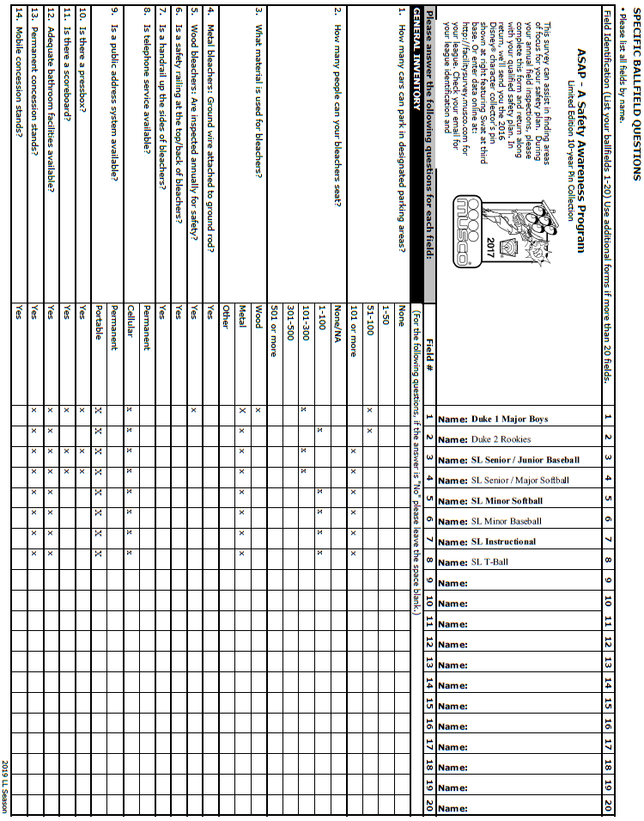

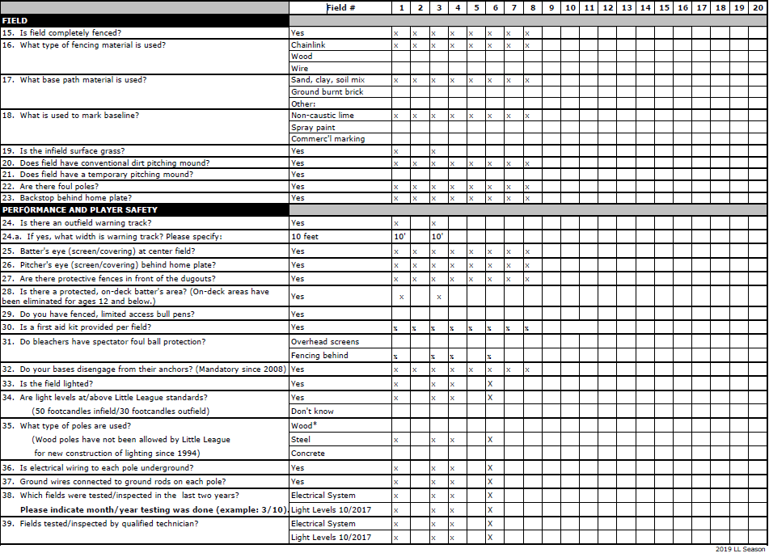

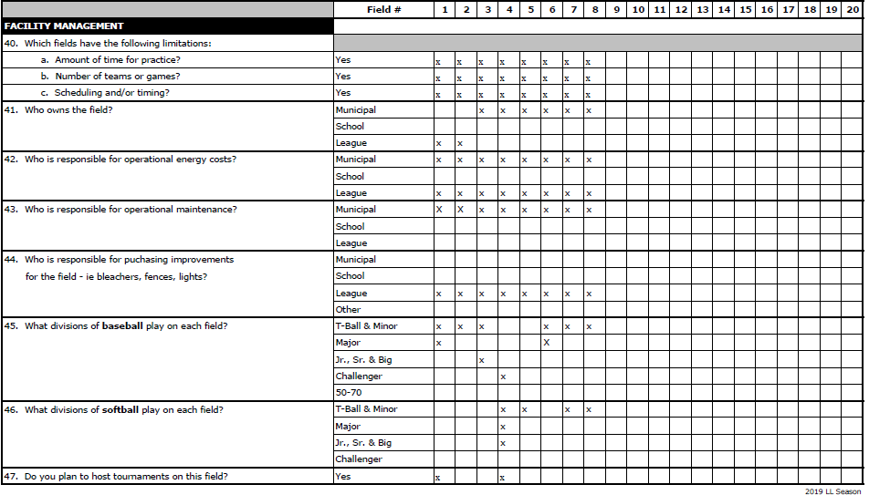

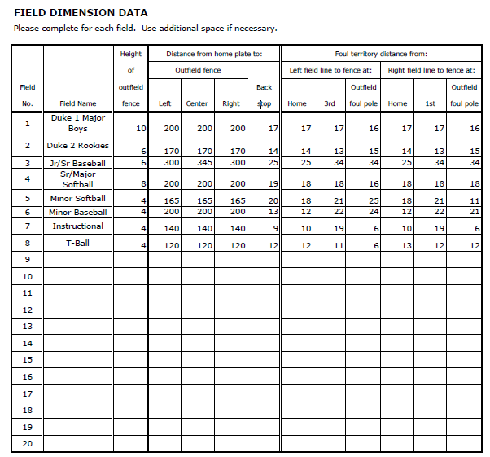

**DUKE BASEBALL COMPLEX**

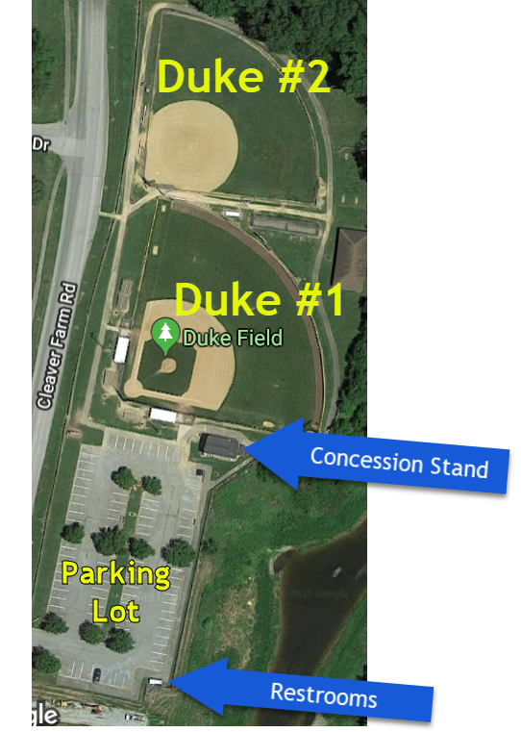

**Silver Lake Baseball Complex**

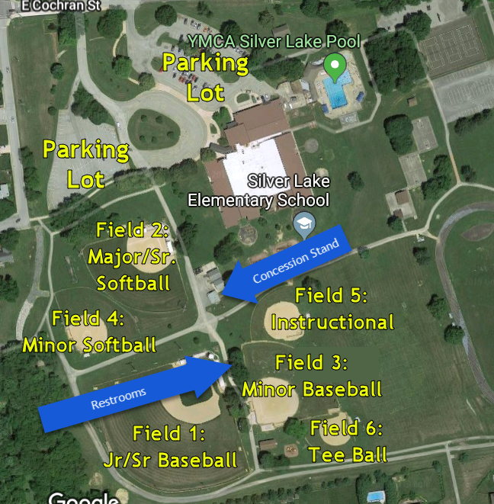

**Equipment Safety Audit**

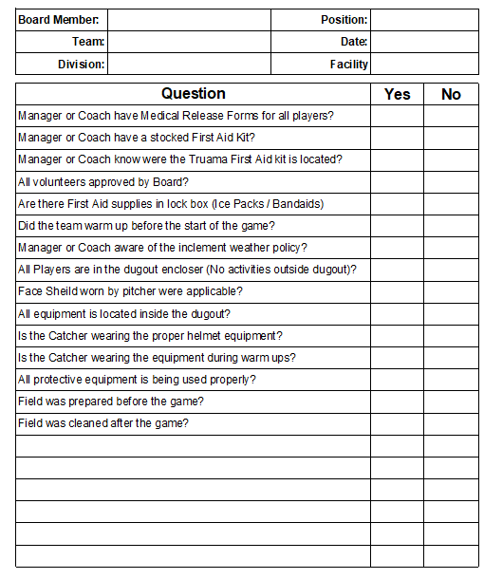

**Suggested Equipment Checklist:**



**CONCESSION STAND INSPECTION**

**AND HEALTH TRAINING**

**1. Scheduled on or about March 30, 2021 to be conducted by Certified Restaurant Trainer and ServSafe Certified and the Delaware State Board of Health**

**2. Procedures for Silver Lake and Duke Field Stands are established during the inspection by the Concession Stand Committee.**

**3. Distributed to Each Member of the Concession Stand Committee and Posted at Silver Lake and Duke Field Concession Stands as Applicable**

**SILVER LAKE OPERATING PROCEDURES FOR WORKERS**

**OPENER RESPONSIBILITIES:**

1. Flip switches in front to turn on unit on counter and set temperature to 300 degrees. Set dial to 375 for fryer unit. Turn on exhaust fan. Give fryer about 10 minutes to heat and lower the fryer basket into the hot oil. Do not pre-cook mozzarella sticks or nuggets.
2. Turn on hot dog griller. Fill the grill with hot dogs and sausages and set to high. Cut thru sausages to keep them from rolling off griller. If dogs are frozen, take about 15 and put in blue Pyrex bowl and microwave for about 5 minutes and then put on griller.
3. Turn on cheese warmer and turn knob to highest temperature setting.
4. Turn on warming light
5. Instructions for pretzels, mozzarella sticks and nuggets are on the wall. Put about 12 pretzels in the warmer
6. Fill coffee pot with hot water and plug in
7. Roll table outside. Make sure vinegar, relish, salt and old bay containers are full. Fill napkin dispenser if necessary
8. Open serving window
9. Review price list, location of supplies and answer any questions worker might have

**SILVER LAKE OPERATING PROCEDURES FOR WORKERS**

1. RECORD DATE, SIGN YOUR NAME, PRINT YOUR CHILD’S NAME AND PRINT TEAM NAME ON SIGN-IN SHEET
2. Keep at least 6 orders of fries, 8 hotdogs and 6 sausages (3 mild and 3 Hot) under the warmer. Adjust the temperature on hot dog griller according to need. Cook nuggets and mozzarella sticks when ordered. Instructions for cooking the nuggets and mozzarella sticks are on the wall near fryer.
3. Check all condiments and napkins on outside table, refill as needed and wipe off table when needed.
4. Check instructions for pretzels and keep about 12 in warmer
5. Last shifts workers should check food supply during the 5th inning of the last scheduled game. NOTE: STOP COOKING AT 8:45pm AND CLOSE WINDOWS at 9:15pm
6. Last shifts workers: Clean hot dog griller (instructions on the wall). Turn off fryer (dial on the left side inside door). For fryer unit on counter, switch is located on the front of the unit. Lift heating element out of unit (it locks into place). Unplug the cheese heater. Take can out of unit, cover with foil and put in refrigerator. Wipe down all counters. Unplug coffee machine and empty any left over coffee and grounds.
7. Dump the trash and sweep the floor. Place all empty bread trays outside the side door of the stand. Bring condiment cart inside. Wipe down the top of the table and move the mustard/ketchup unit to wipe underneath. Put relish and vinegar in refrigerator. Do not refrigerate mustard or ketchup.
8. Try to keep no more than two $ 20’s, four $ 10’s four $ 5’s and about fifteen $1’s in a drawer. If you have more than this, put money inside bank envelope, (located on shelf near safe). Log amount deposited before dropping in safe. Make sure all money drops into same
9. SMALL CHILDREN ARE NOT ALLOWED IN THE STAND. Workers are entitled to a soda, fries and either a hot dog or sausage for themselves. **NO “FREEBEES"**

**SILVER LAKE OPERATING PROCEDURES FOR WORKERS**

**CLOSER:**

1. Make sure all cooking appliances are turned off. Wet mop floor if necessary. Do inventory check and make a list of needed items.
2. Drop all money into the safe (Keep out two $ 20’s, four $ 10’s four $ 5’s and fifteen $1’s and place inside money pouch and store it). Log in amount deposited before dropping into the safe. Make sure money drops into the safe.
3. Drop front window covers down, hook inside and put lock through hook but do not lock.
4. Lock and dead bolt rear door, turn off lights and lock the door behind you. Make sure the equipment door has been locked

**Duke Operating Procedures**

# OPENER RESPONSIBILITIES:

"'

1. Open door on fryer and turn knob to *355* degrees.

Turn on exhaust fan (switch located to the left of the fryer). Give fryer about 5 mins. to heat and lower the fryer basket into the hot oil. Fill both sides of fryer with fries. **DO NOT SET TEMPERATURE HIGHER THAN** ***355****.*

. ... , .·•

1. Turn on hot dog griller. Fill the grill with dogs and sausages and set to high. Cut the sausages almost all the way through, otherwise they will roll off the griller. When wrapping sausage, twist both ends of foil for hot sausage but only one end for mild sausage. IF DOGS ARE STILL FROZEN, PUT ABOUT 15 DOGS IN BLUE PYREX BOWL AND MICROWAVE FOR ABOUT *5* MINUTES, THEN PUT BACK ON GRILLER.
2. Put can of cheese into heater. Turn on heater and set temp knob to highest setting (located behind the unit).
3. Turn on warmer lights.
4. Instructions for mozzarella sticks, chicken nuggets and pretzels are located on the pretzel warmer.·
5. Put table outside and fill condiment containers [ketchup, old bay, salt, vinegar, and relish] and napkin holders and put on table.
6. Unlock serving window.
7. Review price list, location of supplies and answer any questions workers might have.

**Duke Operating Procedures for Workers**

1) RECORD DATE, SIGN YOUR NAME, PRINT YOUR. CHILD'S NAME, AND PRINT TEAM NAME ON SIGN-IN SHEET.

1. Keep at least 6 orders of fries, 8 hotdogs, and 6 sausages (3 *hot* and 3 mild) under *the* warmer. Adjust temperature on hot dog grill according to need.
2. Cook the nuggets and mozzarella sticks when ordered. Instructions for cooking, nuggets and mozzarella stick are on the pretzel warmer.
3. Check all condiments and napkins on table outside, refill if needed before you finish your shift. Check outside fable occasionally and, if necessary, wipe off table. Check temperature of cheese wormer. Knob is located on the back of the unit; set to mid-point.
4. Turn on pretzel unit. Instructions are on door of pretzel unit.
5. Last-shift workers should check food supply during the top of the 5th inning of the 2nd game. **NO FOOD SHOULD BE COOKED AFTER THE 5TH INNING.**
6. Last-shift workers should start cleaning up during the top of the 6th inning. Turn off fryer (dial on the left side inside door). Unplug the cheese heater and take the can of cheese out of the wormer and put foil on top of can and put in the fridge. Clean salt out of pretzel unit. Wipe all counters. Dump left-over coffee arid grounds.
7. Empty the trash and sweep the floor. Place all empty bread trays outside the front door of the stand. Make sure all condiments are filled, wiped off and then put in fridge. · Wipe off table, fold and bring inside stand.

**Duke Operating Procedures**

CLOSER: ·

# Make sure all cooking appliances are turned off. Sweep floor and wet mop if necessary Make sure containers of ketchup, vinegar and relish are filled. Do an inventory check and make a list of needed items. Empty trash.

# _ _ Drop all money in the safe [keep out two

$20's, four $10's,four $5's and fifteen $1's and put in pouch and then put in freezer. Make sure money drops into the safe.

# Record the amount of the deposit on -the deposit record above safe.

* 1. Lock front windows.

# Turn **ON** the recessed overhead outside

lights and make sure to lock the door behind you.